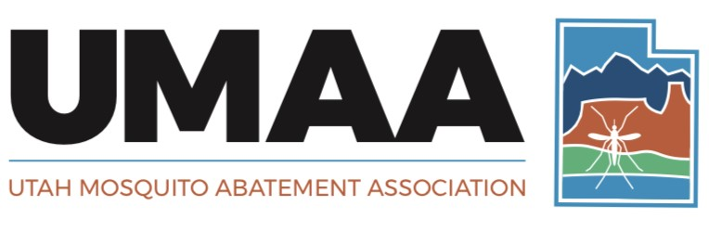

*Individuals and Organizations Devoted to Enhancing the Health*

*and Quality of Life through the Suppression of Mosquitoes*

**Saltgrassroots Travel Award Application Form**

|  |  |
| --- | --- |
| **Applicant’s Name:** |  |
|  | Last M.I. First |
| **Organization:** |  |
|  |  |
| **Department:** |  |
|  |  |
| **Address:** |  |
|  |  |
|  |  |
| **Phone Number:** |  |
|  |  |
| **Email:** |  |
|  |  |
| **Potential Presentation/Poster Title:** |  |
|  |  |
|  |  |
| **Signature & Date:** |  |

Please Attach to this Form:

A statement of purpose in two pages or less.

One letter of recommendation from a supervisor, board of director, or colleague.

(Additional information may be requested at the discretion of the UMAA Awards Committee)

**Please submit this form and all attachments to the UMAA Awards Committee no later than 5:00 pm on 30 September of each year.**