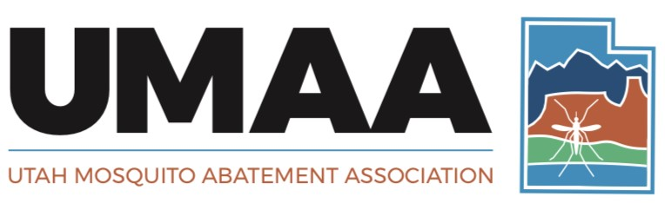

*Individuals and Organizations Devoted to Enhancing the Health*

*and Quality of Life through the Suppression of Mosquitoes*

**Dickson-Nielsen Scholarship Application Form**

|  |  |
| --- | --- |
| **Applicant’s Name:** |  |
|  | Last M.I. First |
| **University:** |  |
|  |  |
| **Department:** |  |
|  |  |
| **Address:** |  |
|  |  |
|  |  |
| **Phone Number:** |  |
|  |  |
| **Email:** |  |
|  |  |
| **Research/Project Title:** |  |
|  |  |
|  |  |
| **Signature & Date:** |  |

Please Attach to this Form:

A research statement of two pages or less.

A curriculum vitae or resume.

A letter of recommendation from your major advisor or manager/director.

(Additional information may be requested at the discretion of the UMAA Awards Committee)

**Please submit this form and all attachments to the UMAA Awards Committee no later than 5:00 pm on 30 September of each year.**